1. List all classrooms with a capacity greater than 50.
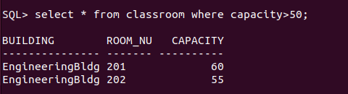

2. Find the names of all instructors in the "Computer Science" department.
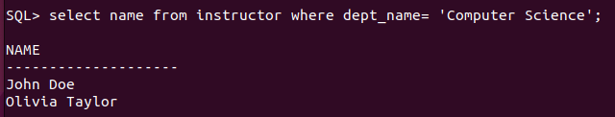
3. Retrieve the titles of all courses offered in the "Spring" semester of 2024.
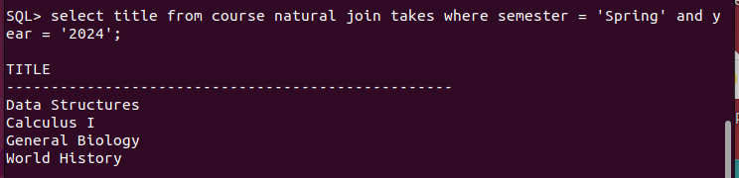
4. List all students who have taken more than 30 total credits.
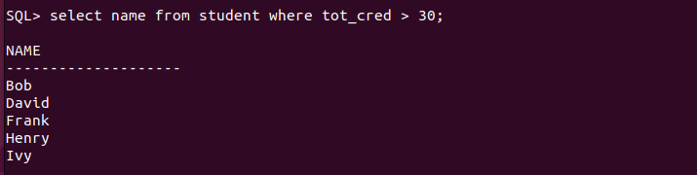
5. Find the names of all departments with a budget greater than ₹1,000,00.
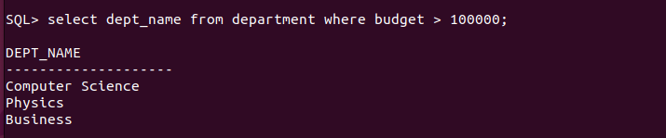

6. List all departments and their respective buildings.
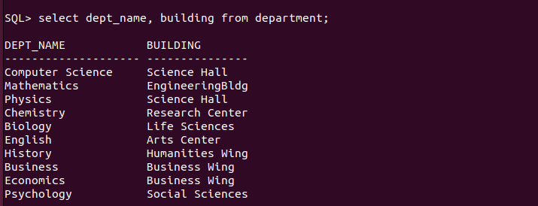

7. Find the names of all students enrolled in the "Physics" department.
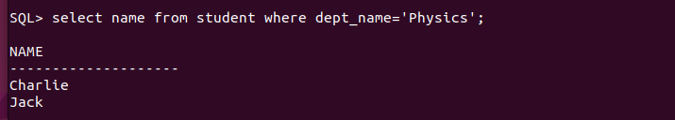
8. Retrieve the titles of all courses with 3 credits.
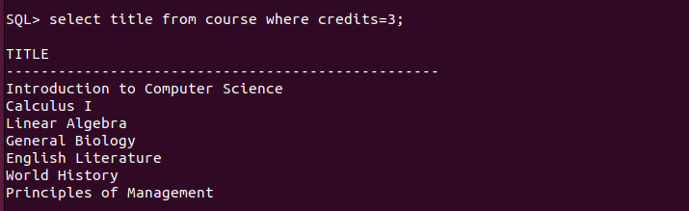
9. List all instructors who do not belong to any department.

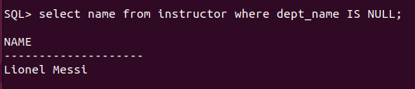

10. Find the total number of classrooms in each building.
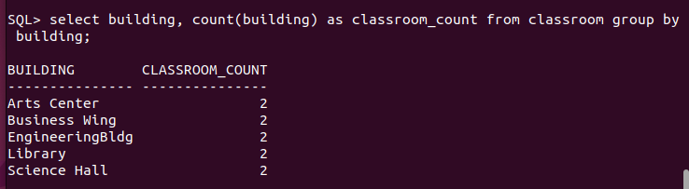
11. List all courses taught by the instructor with ID "I0101".
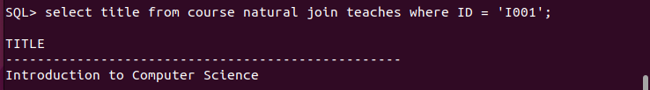
12. Find the total number of students enrolled in each department.
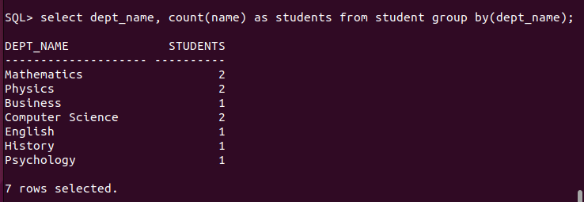

13. Retrieve the names of students who have taken the course "CS-101" and received an "A" grade.
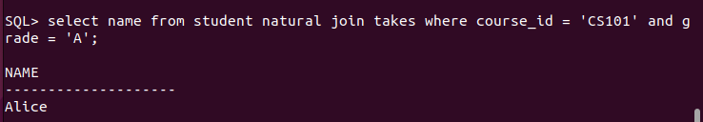

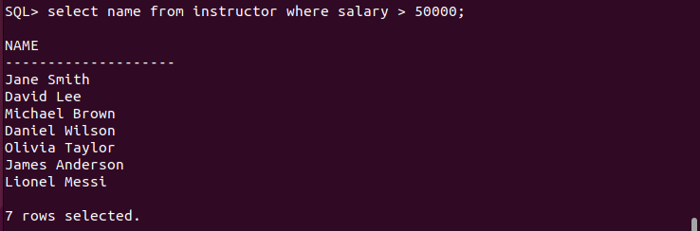
14. List all instructors who earn a salary greater than ₹50,000.

15. Find the average salary of instructors in each department.
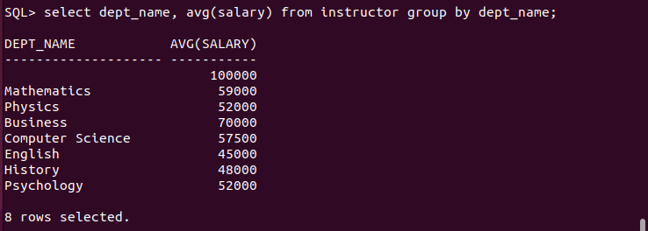

16. Retrieve the names of students who have not been assigned an advisor.
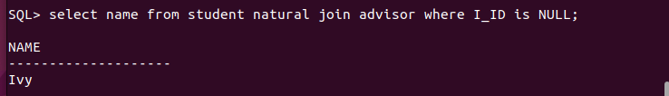

17. List all courses that have "CS-101" as a prerequisite.
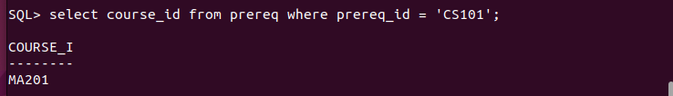

18. Find the total number of sections taught in each building.
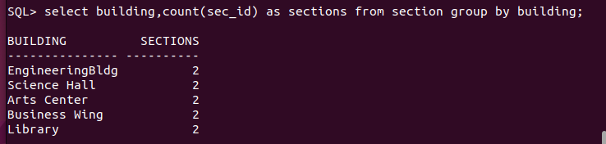
19. Retrieve the names of students who have taken at least one course in the "Fall"
semester of 2023.
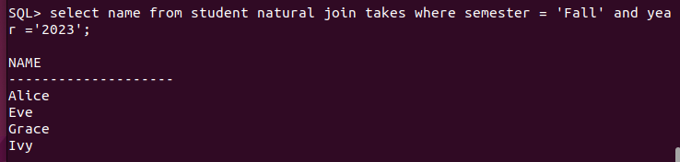
20. List all classrooms that have not been assigned to any section.
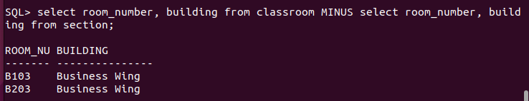
21. list all courses offered by the “Mathematics department.

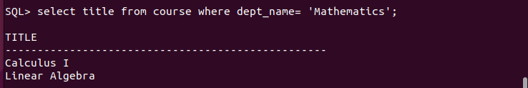
22. Find the names of students who have taken courses in both “Fall” and “Spring semesters.

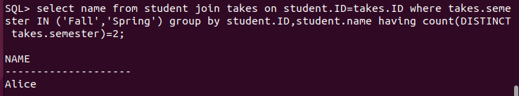
24. List all courses that have no prerquisties.
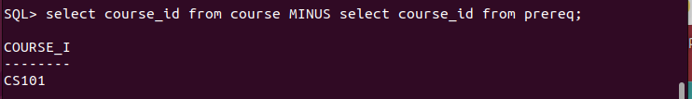
25. Find the average number of credits taken by students in each department.

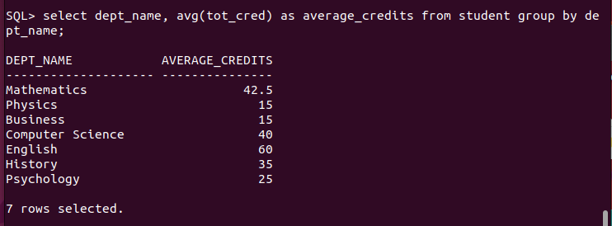
26. Retrieve the names of students who have taken courses with the instructor "Einstein".
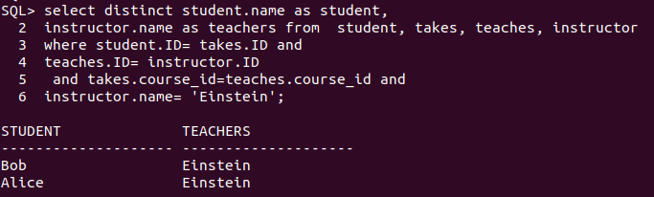
27. List all sections that are held in the "Library" building.
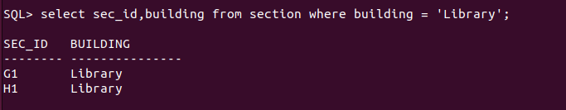
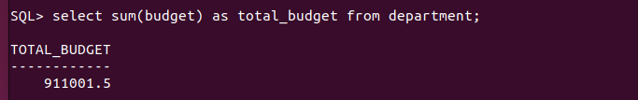
28. Find the total budget allocated to all departments.

29. Retrieve the names of students who have taken at least one course with a grade of "B".
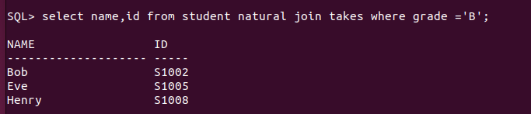
30. List all instructors who have not taught any course.

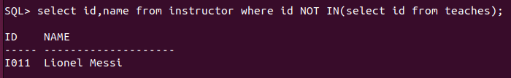
31. Find the names of students who have taken all courses offered by the "Computer Science"
department.
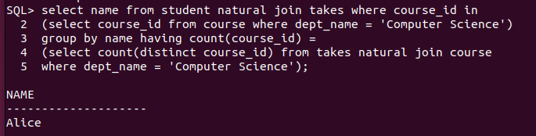
32. Retrieve the names of instructors who have taught every course in their department.

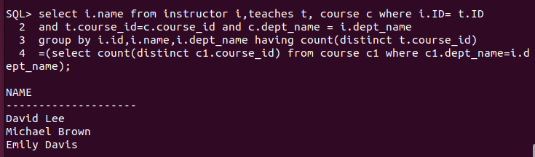
33. List all students who have taken at least one course with every instructor in their department.

